**Project plan**

***‘Alpha’***

*Erion Kapaj*

***Eindhoven***

|  |
| --- |
|  |
|  |
|  |
|  |

#### Version

|  |  |  |  |  |
| --- | --- | --- | --- | --- |
| **Version** | **Date** | **Author(s)** | **Amendments** | **Status** |
| 1 | 16/02 | Donald, Martin, Matthew, Kingsley | Creation of the project plan’s first version / leader made editions | In progress |
| 2 | 02/03 | Mariyana, Donald, Vanesa | Making detailed changes in order to present our project plan and be more specific | In progress |
| 3 | 07/03 | Vanesa, Kingsley, Donald, Martin, Khoa | Adding mission statement, project details, user requirements, functional requirements, database diagrams | In progress |
| 4 | 09/03 | Vanesa, Mathew, Donald | Editing details; making the file even more specific | Finalising |

**Inhoudsopgave**

1. Project Assignment 3

1.1 Context 3

1.2 Goal of the project 3

1.3 The assignment 3

1.4 Scope 3

1.5 Conditions 3

1.6 Finished products 3

1.7 Research questions 4

2. Approach and Planning 5

2.1 Approach 5

2.2 Research methods 5

2.3 Breakdown of the project 5

2.4 Time plan 5

3. Project organization 6

3.1 Team members 6

3.2 Communication 6

3.3 Test environment 6

3.4 Configuration management 6

4. Finance and Risks 7

4.1 Cost budget 7

4.2 Risks and fallback activities 7

5. Other 8

# Project Assignment

## Context

Erion is a creative artist who is involved in a wide range of art, including painting, sculpture, and photography.

He creates artwork such as: creating small boats for kids to play with them in the lake; human-body type sculptures; paints landscapes and people; loves to paint in a white and da Vinci theme. Nevertheless, he sells his artwork locally now, but he wants to reach a far bigger audience through his website and not only – by having this online platform, it would also be easier for our stakeholder to showcase his artwork to his family and friends.

## Goal of the project

The goal of this project for Erion is to try to showcase his art and to reach a larger audience in a professional and easy to use website in order to gain more customers and to be able to show his art to his friends and family easily.

The project's overall objective is to build a strong tool that will help the artist reach a larger audience, strengthen their brand, and ultimately generate additional commercial prospects. Erion can reach a wider audience and advance his profession with the help of a well-designed website.

## The assignment

This project's assignment is to create a website to clearly and simply showcase Erion's art collection.

The website must specifically be able to display the artist's work and provide information about most of his types of art. The artist's exposure would grow as a result and generate more business opportunities.

## Scope

This section shows an overview of the scope of the project. The scope outlines the deliverables of the project. The project scope is depicted in the table below, showing what the project includes and does not include.

|  |  |
| --- | --- |
| **The project includes:** | **The project does not include:** |
| 1. Computer version website | 1. Payment system for purchasing |
| 1. Mobile version website | 1. Deploy the website to a server |

## Conditions

## Finished products

We will provide an overview of the project's product breakdown structure and a description of each individual product in this section.

1. Project planning and analysis: We will define the project's scope, goal, and stakeholders in this phase. We will also develop a roadmap. We will decide the project's timeline and the resources needed to finish it successfully during this phase as well. This is necessary to make sure the project has a clear direction and is in line with the goals and objectives of the client.
2. Research and interviews: The sub questions that have been developed from the key stakeholder's art's current situation will be identified in this phase. These questions can each be answered by conducting research and interviews
3. Prototyping.
4. Design and development.

The figure below is the product breakdown structure which we have utilized to analyse, record, and present the hierarchical structure of the results the project will produce.

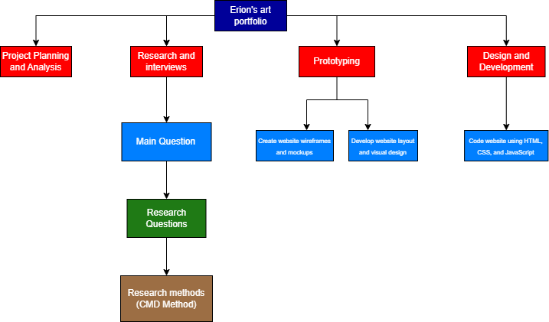

## Research questions

We have developed the main question, which we have further divided into sub-questions, based on Erion's goal. The primary question and the research questions that have been derived from it will be described in this section.

**Main Question**: How to present Erion’s art portfolio in a clear and easy manner using a website in order to showcase his personality to his audience through his work.

• **Who is his target audience?** This is crucial because it increases the likelihood that the product will be a success when it is eventually introduced to his target market. We can modify the features and design of the product to match the unique demands and preferences of the target audience by knowing who they are.

• **What art categories does he want on the website?** His art should be exhibited in a variety of categories to assist in organizing the information, enhance user experience, and encourage exploration.

• **What is his story? Does he want to share more about it with his audience?** This is crucial because it enables us to recognize the stakeholder's unique abilities, grasp his artistic style and vision, and helps build customer trust.

• **Should the website have a dedicated section for Erion’s resume, bio, and past exhibitions to provide context**  **for his work?**  A section that shows Erion’s past exhibitions and resume can be an important feature because it shows potential customers what makes him uniquely qualified.

• **What type of content should be included on the website to showcase Erion’s art effectively?** Understanding the right kind of content to post on the website is essential since it may have a big impact on both the artist's and the website's success. It can help to attract the right audience and encourage engagement.

• **What is the best way to organize the art pieces on the website to ensure a cohesive presentation?** This is essential in order to know how to arrange art elements on a website to create a unified presentation that is visually appealing, simple to use, supports his brand, tells a story, and ultimately increases sales.

• **What are some best practices for including artist statements and descriptions of the artwork on the website?** A fantastic method to provide his website visitors insight into his creative process and the purpose behind his artwork is to include artist statements and descriptions of his artwork.

**•** **Should the website include a blog or news section to keep visitors engaged and up to date on Erion’s latest**  **work?** It's crucial to decide whether the website should have a blog or news section because doing so can help to keep visitors interested in and informed about Erion's work.

**•** **What are some strategies for encouraging audience engagement and feedback through the website?** This is crucial information to understand since promoting audience engagement can create a more engaging website that is interactive. Social media integration, for instance, can increase visibility and enhance audience participation and contribute to a more collaborative and engaging user experience for his audience.

**•** **Should the website include a contact form or other methods for potential clients to get in touch with Erion?** This will help with easy communication and show professionalism. Overall, a contact form feature is an effective way to communicate with the visitors of the website. It can also help Erion better understand his audience and improve the website and services.

**•** **What are some best practices for maintaining and updating the website over time to keep it fresh and engaging?** This is essential for determining whether we need to keep the design up to date, incorporate new technology, regularly test and improve so it can continue to attract and retain visitors and customers in the future.

# Approach and Planning

## Approach

For our approach, we are utilizing the DOT Research Framework's CMD methods as co-creation, co-reflection, context mapping, design pattern research, inspiration wall, interview, peer review, prototype, quality review, requirement list, test report, and usability testing, which are media-design friendly.

**2.1.1 Test Approach**

We are going to send our prototype to friends and fellow students to test it and say their opinions about it, and what were their thought while working with it. After that, we are going to change the specific details and structures based on the feedbacks we received to make the best possible user-centred prototype before starting to implement the code.

## Breakdown of the project

The project’s plan will follow this path: We will start with the Empathize phase, where we will focus on pre-research of our customer and creation of an empathy map, as we are going to conduct interviews based on sub-questions, uncover emotions of the stakeholder, and seek stories. After that, we will start with the Define phase, where we will be speaking of the Plan Document and creating the Project template, which includes working on team mission statement, containing the following points: Project details, User requirements, Functional requirements, and Database flow diagrams. We are going to work on this phase with some focus on persona, manifesto, user scenario, as we are going to reframe and create human-centric problem statements, identify meaningful surprises and tensions, and infer insights. Onwards, the ideation phase will start based on focusing on techniques, such as Sketching, Brainstorming, Brainwriting, Worst idea, which indicates that we will brainstorm radical ideas, build on other’s ideas, and suspend judgment. After all these phases are fulfilled, we will start the Prototype phase, where we will be focusing on basic explanations of the relation between the project and the prototyping in low, mid, and high fidelity. We will be paying attention to media deliverables from other subjects relevant to the project. Furthermore, we are going to create lo-res objects and experiences, make a role play to understand the context and features, and quickly build to think and learn how to provide the best possible product. After we have final prototype, we are going to start the Testing phase, where we will be giving some simple focus on different testing methods and making iterations, as we’re going to go through tests with customers to refine solutions and gather data on probable problems, gain deeper empathy and embrace failure. In addition, there will be an Assess phase, where we will be openly giving and receiving feedback from our mentors, go through guidelines for evaluating project work critically and, in conclusion, finalize our goal.

## Time plan

Sprint 1: Week 1-3: Introduction

Sprint 2: Week 4-7: Start of the Define phase

Sprint 3: Week 8-11: Start of ideation phase with basic focus on ideation techniques

Sprint 4: Week 12-16: Start of the Prototype and Testing phase

Total amount of time needed for the final project: around 16 weeks.

|  |  |  |
| --- | --- | --- |
| **Phasing** | **Start** | **Ready** |
| Empathize | Week 1 | Week 4 |
| Define | Week 5 | Week 7 |
| Ideate | Week 8 | Week 11 |
| Prototype | Week 12 | Week 14 |
| Test | Week 14 | Week 16 |
| Assess | Week 14 | Week 16 |

# Project Organization

## Team members

|  |  |  |  |
| --- | --- | --- | --- |
| **Name + Phone + e-mail** | **Abbr.** | **Role/tasks** | **Availability** |
| Donald Umoru. +31687832140  [d.umoru@student.fontys.nl](mailto:d.umoru@student.fontys.nl)  Mileva Mariyana. +359888330716  [m.mileva@student.fontys.nl](mailto:m.mileva@student.fontys.nl)  Izekor Kingsley. +31610137866  [503216@student.fontys.nl](mailto:503216@student.fontys.nl)  Martin Alashki. +359896333152  [501076@student.fontys.nl](mailto:501076@student.fontys.nl)  Mathew Tendean.  +31627925695  [500685@student.fontys.nl](mailto:500685@student.fontys.nl)  Taneva Vanesa. +359888559665  [500927@student.fontys.nl](mailto:500927@student.fontys.nl)  Dang Khoa Nguyen  +31616247755  [458834@student.fontys.nl](mailto:458834@student.fontys.nl)  Jaganjac, Amer A.  Metaxas, Georgios G.  Reuther, Aljoscha A.  Roosen, Frank F.M.J | D.U  M.S  O.K  M.B.A  M.T  V.M.T  D.K | Member  Member  Member  Member  Member  Member  Member  Teacher  Teacher  Teacher  Teacher | 4 days a week, during school hours  4 days a week, during school hours  4 days a week, during school hours  4 days a week, during school hours  4 days a week, during school hours  4 days a week, during school hours  4 days a week, during school hours |

## Communication

We communicate in person at campus online through different medium, we have a group section on WhatsApp, Microsoft teams and Discord. We attune with each other in a very cordial way. We have decided as a group to coordinate, respect, understand and support each other. These atonements will take place every time we work on our project and every time, we have a group meeting.

## Test environment

*Computers, big-screen device, mobile phones*

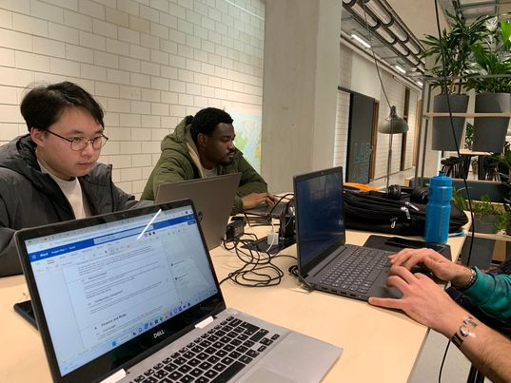

## Configuration management

We will use Git as our version control software and GitLab as git management software while working on the project. It would allow everyone in the group to work on the same project at the same time. It also gives us access to previous versions of the project, so if something goes wrong, we can always undo the changes.

# Finance and Risks

## Cost budget

This project requires software to write and/or manipulate HTML, CSS or JavaScript program languages, view and edit images, and create PNG or vector files for logos and/or icons.

The code can be handled by VS Code or Notepad++, which are free.

Editing and creating images can be handled by Clip Studio Paint, Photoshop, Canva which one of us has access to.  
Otherwise, it can be done using free software such as GIMP or Inkscape.

However, if the team is adamant on using industry standard methods (the Adobe Creative Cloud), it will cost $130/year. However, one license works on two devices. (Roughly $65/year per student).

## Risks and fall-back activities

Risk is a potential occurrence that could happen or not during a project.

Risk assessment is the process of finding and analyzing potential risks that could cause delays as well as making decisions “on the tolerability of the risk on the basis of a risk analysis" while taking influencing factors into consideration.

In this section, we'll identify and assess the factors and risks that could have a negative impact on the outcome of our project.

Using the table below, we have identified the following risks that could occur during this project and how we plan to mitigate them.

|  |  |  |
| --- | --- | --- |
| Risks | Prevention | Contingency (Fall-back plan) |
| A member is unable to attend. | During the weekly meeting, discuss next week’s availability so that the team is prepared.  If the matter is urgent, notify the team. | Normalization of online communication, so that even when a member cannot attend in person, the group can stay informed and effective. |
| Loss of data/progress due to device malfunction. | Maintain your devices and handle them with care. | Pull and push changes to git, this way progress is stored in the cloud and not on a single device. |
| A shareholder cannot be contacted. | Keep notes of when and how they can be contacted, plan question-asking around these notes. | Ask the teacher, as he should have contact with the shareholder. |
| Confusion among members. | Each meeting, we must discuss the tasks for the next week. Use a method to track who is working on what. | Communicate with other group members. Call a group meeting if possible and discuss the progress. |
| The product did not meet expectations. | Thoroughly understand the client’s request, take this into account when working on the product. Check once again before presenting to client. | Check the product for the points where it did not meet expectations, then fix said problem. |
| Insufficient technical knowledge to create product. | Pay attention to technical lectures and keep notes. | Ask other group members or the teacher for help on the matter. |

# Other

*<< Describe here everything that is relevant but that you cannot put elsewhere in the document.>>*